Lani & the Deities

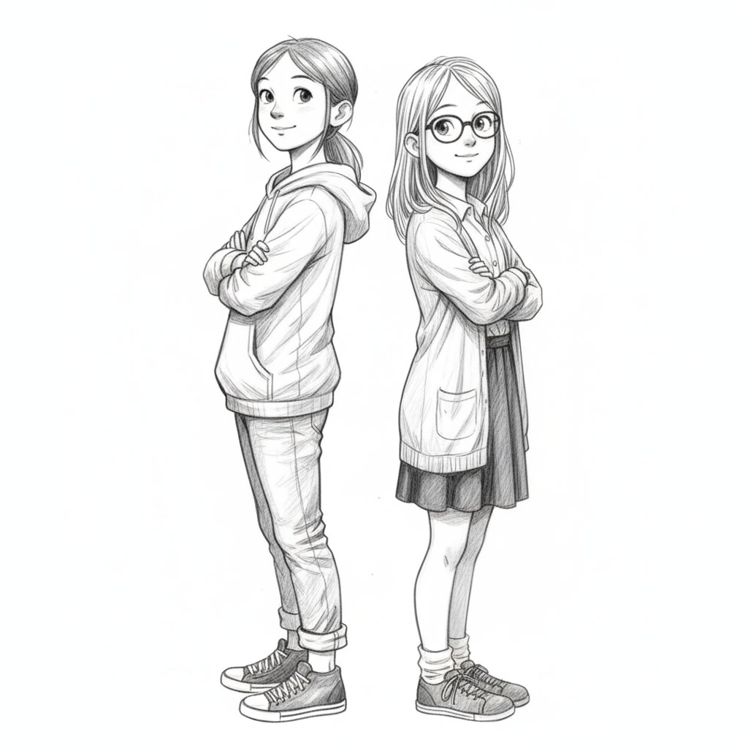

Prologue

Thunder rolled across the valley - except it wasn't thunder. It was stone.
Hussite siege engines hurled boulders at Karlštejn, and each impact shuddered through the fortress like a giant fist. Firepots arched over the battlements and burst in showers of sparks.
At the front strode Jan Žižka, the one-eyed hero of the people. His single good eye blazed.
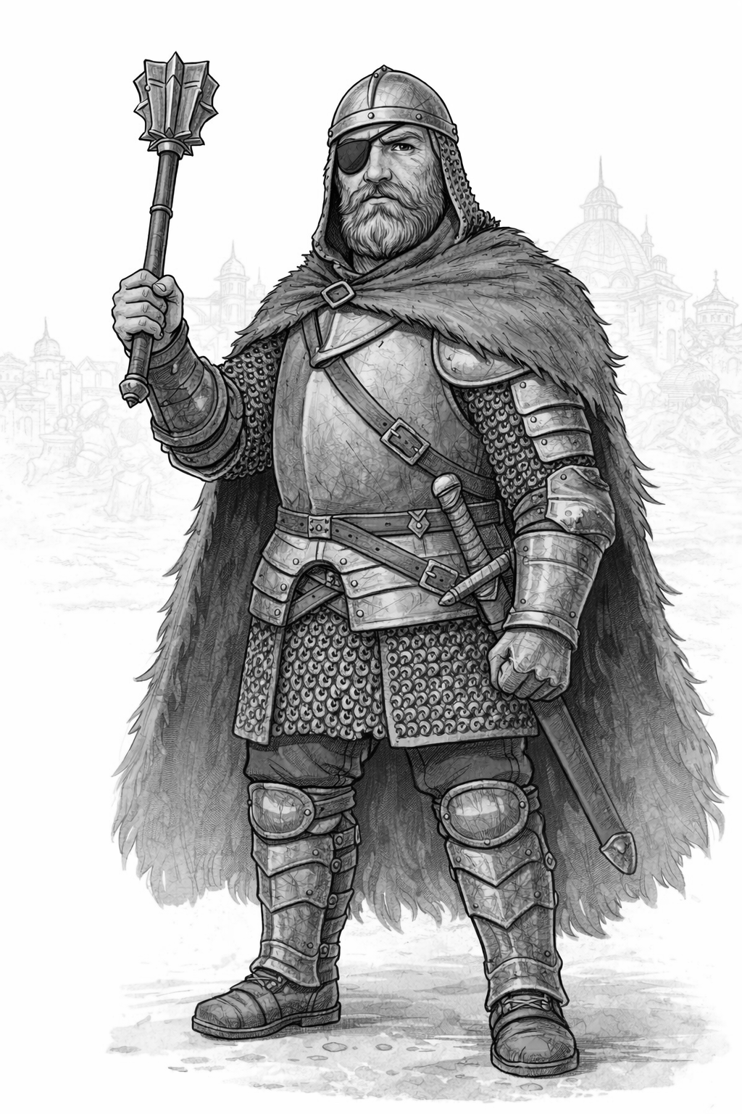
"Forward!" he roared.
His warriors surged. Ladders slammed into stone. Shields clanged. The night filled with steel and shouting.
The first great gate gave way, and the castle fought back. Arrows hissed from the towers. Boiling oil sizzled as it poured. Defenders bellowed from the walls.
Nothing slowed Žižka. His iron mace rose and fell like a forge hammer, scattering men as if they were made of straw.
Then, in the heart of the storm, something went wrong.
A bolt of darkness cut through the air - too fast, too sharp to be an arrow. Žižka jerked, staggered, and dropped to his knees. His mace slipped from his hand and thudded into the mud.
The Hussites froze. So did the defenders.
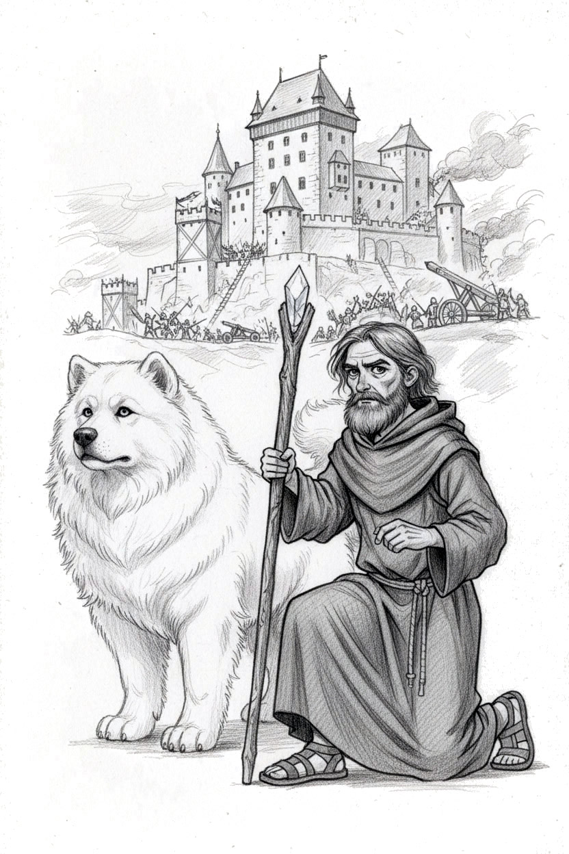
For one terrible breath, even the battle seemed to hold still.
Flames guttered. Men's breath turned to mist.
Through the shattered gate walked a man in brown robes, a staff in his hand. At his side padded a beast of legend, white fur gleaming and eyes burning gold.
Veles. And Dažbog.
They crossed the courtyard as if time itself had thickened around them. Veles stopped and kneeled beside the fallen general.
He murmured to the great hound at his side.
"This isn't good."

Train

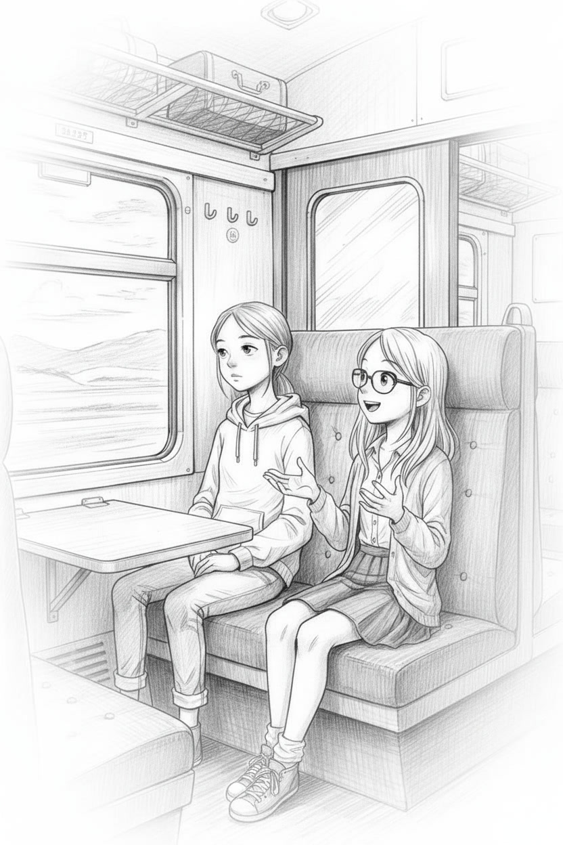

"Trains are the best!"
"You've said that five times, Katchy."
"So? I like trains!" The blonde ball of energy, Katchy to the teachers, Katchy to everyone else, grinned like she'd swallowed a whole firework.
Both girls were thrilled about their latest school trip, though for wildly different reasons. Lani, eleven, red-haired and tall enough to see over most heads, loved one thing: no lessons.
Her best friend loved facts. Especially facts with dates.
Katchy had her history book open on her knees and her phone in her hand, somehow reading from both at once, and loudly enough for the whole carriage to hear.
"Did you know Charles IV…"
Lani clapped her hands over her ears, turned to the window, and pretended she had never met the person sitting next to her.
"Well, we're almost there," Lani muttered when she dared to peek back. Katchy was already scrolling another "10 Fun Facts about Karlštejn" page, beaming at the screen like it was her favorite TV show.
They were on the S7 train with their class. An elderly couple sat nearby, quietly eavesdropping. To Lani's horror, they smiled at Katchy like she was a tiny tour guide.
"Oh, I'd love to hear that," the woman said kindly.
Katchy lit up and launched straight into Karlštejn fortifications. Lani stared out at the passing trees and daydreamed about anything that didn't involve Gothic architecture or holy relics.
Katchy leaned in. "Say 'good day'."
"Why?"
"It's train tradition."
"Talking to strangers is weird."
Still, Lani managed a polite smile and a small "Good day," while Katchy enjoyed the couple's cheerful reply.
As the train neared Zadní Třebaň, the couple gathered their bags.
"We're visiting the castle too," the man said. "But we'll hike up through the forest."
Lani's stomach turned. A 2–3-kilometre uphill hike sounded like a very effective way to ruin a perfectly good day.
"Sounds... lovely," Lani said through her teeth.
"Okay, everyone, please gather your things," Ms. Brosková called. "Next stop: Karlštejn."
"Woohoo! We're finally there!" Katchy beamed, practically bouncing.
"Yeah. Finally," Lani deadpanned.
"Miss Cloud?" Ms. Brosková appeared beside them like a quiet ninja. "A word."
Lani straightened. "Yes, Miss?"
"No sarcastic comments while the guide is talking."
"What?" Lani hissed. "I've already been forced to listen to every Karlštejn fact on the internet. Now I have to hear it all again???"
"Yes," Ms. Brosková said, smiling so sweetly it looked painful. "And if you don't, you know what happens."
"What? Detention in a library? Does the castle even have a library?" Lani asked, half-joking, half-hoping.
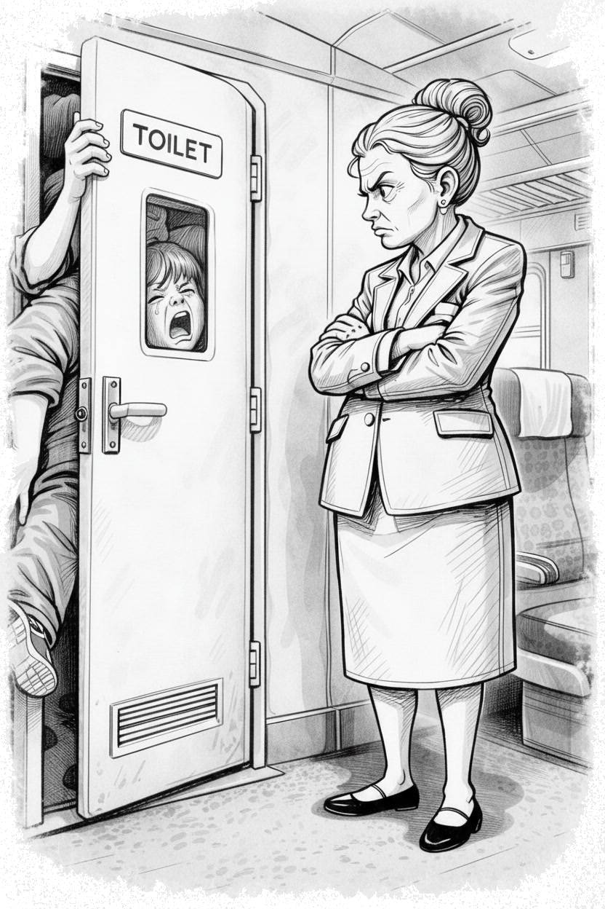
Their teacher didn't answer. She simply raised an eyebrow and marched down the aisle to deal with the boys, who were having a competition to see how many of them could fit inside the train toilet with the door closed.
"Actually," Katchy whispered urgently, "they wouldn't have said 'library'. It would've been 'bibliotheca'…..Or something more... Latiny."
"Latiny?" Lani stared at her. "That's not a word."
"Mrs. Brosková!" Katchy squealed. "Tell her. Latiny is a word!"
"Latiny is an adjective," Mrs. Brosková called back without turning. "Informal, but valid. It means 'having the flavor of Latin'."
She opened the toilet door.
Eight boys tumbled out at once, yelling.
Ms. Brosková pinched the bridge of her nose, then pointed at their bags. "Everyone off. Now."
The class poured down the steps, as the train slowed into Karlštejn station. Lani sighed dramatically.
"Here's to another boring school trip," she muttered.
Katchy skipped in front of her. "Hey. You never know. It might be fun. Or magical."
"Fun?" Lani sniffed. "Doubt it."

Whispers

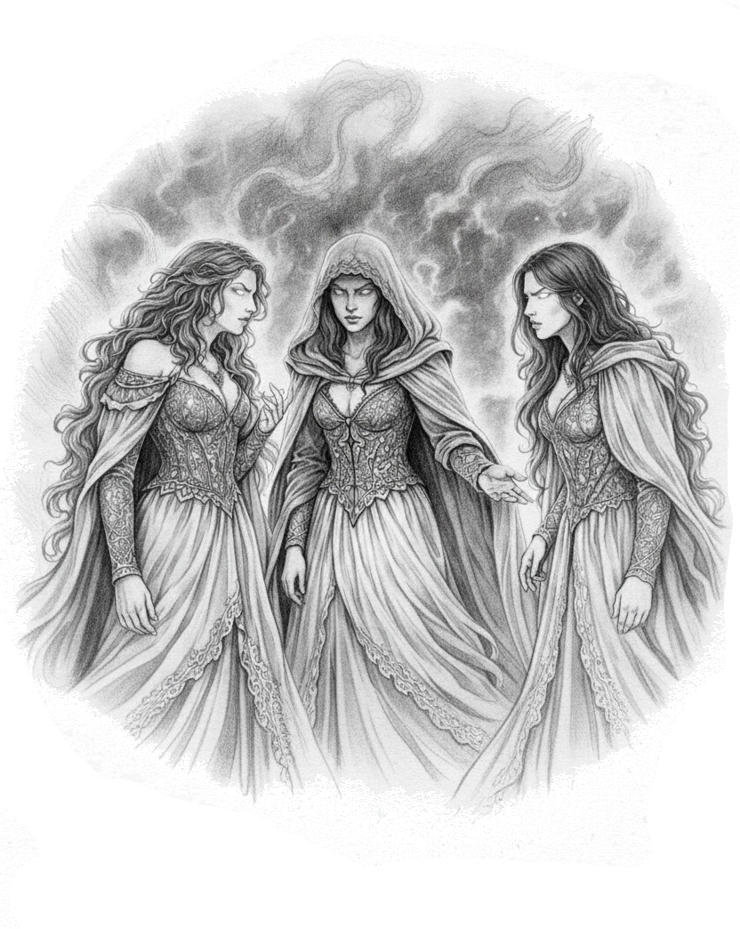
They watched from a wind-whipped hill: three figures cut from shadow and starlight.
Below, Karlštejn crouched under a bruised sky. Smoke curled from shattered towers. War drums rolled up the slopes like distant thunder. In the valley, men shouted and steel rang; arrows stitched the air; the fortress fought as if the world might end by morning.
For a long moment, none of the three spoke.
Then the leader lifted a pale hand.
Rozhanitsy.
Her voice drifted down the hill like a bell in the dark. "Sisters... she has made us more."
Beside her, Sudenitsy and Narechnitsy answered together, a single chime. "Yes, Rozh."
Rozh's eyes, molten gold, fixed on the burning castle. "Our mistress has toyed with the destinies of men again. Now she wants the holy relic."
"The cross," the other two murmured, as if the word itself tasted of power.
Rozh smiled, small and sharp. "A fragment of the True Cross lies here. The piece that matters."
Suden's fingers flexed, impatient. "Then take it."
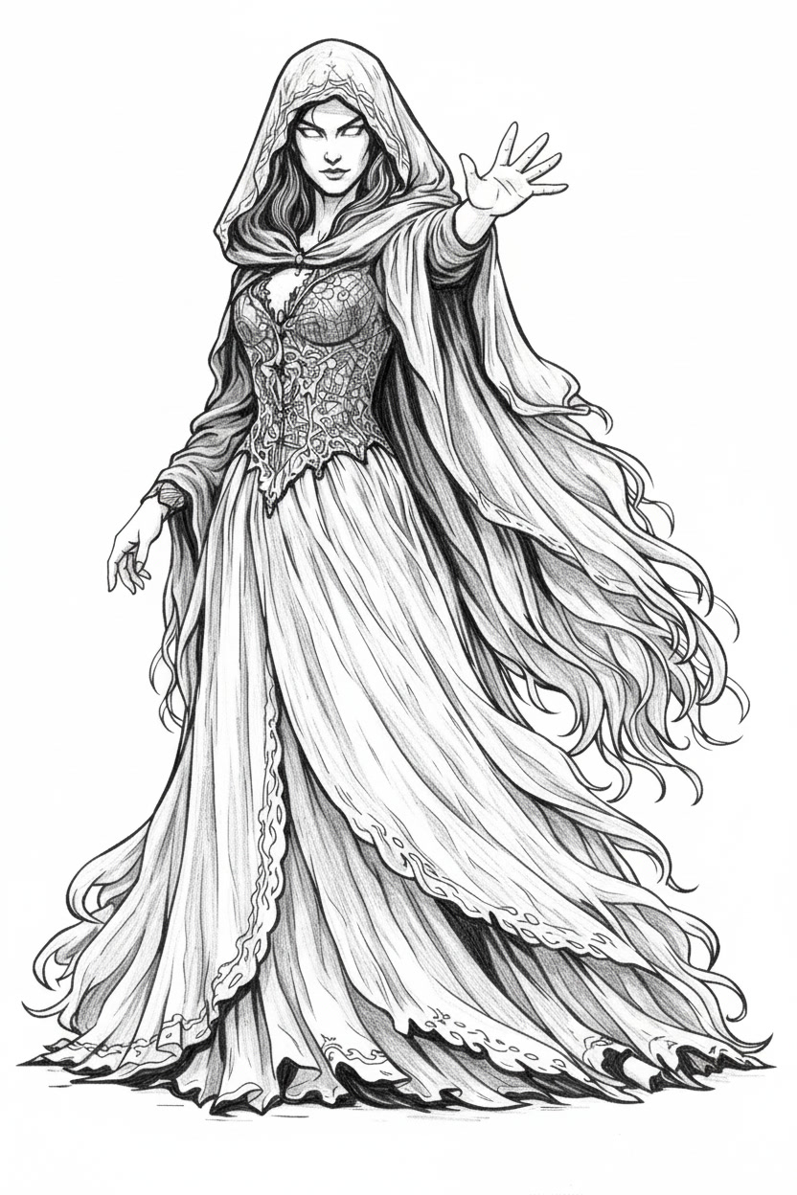
"It is hidden," Rozh said. "Bound to this place. Protected." Her gaze narrowed. "But war opens doors. When the one-eyed general falls, fate will grant us a moment."
Nare's mouth tightened. "Veles won't sit still."
"Of course he won't." Rozh's smile didn't reach her eyes. "He schemes. He keeps his hound close. We will draw him away, scatter his attention, and step into the dark between heartbeats."
Suden gave a pleased little sniff. "Death and distraction. That I can do."
Below, the castle hissed and cracked like old parchment.
Nare's worry slipped out. "And the girl?"
Suden whipped around. "What girl?"
"The Nexus," Nare said, folding her arms. Childlike and fierce all at once. "The one with the dawn-sword. If she joins hilt to blade..."
Rozh's fingers tightened around a thread of wind. "The blade is not whole. Without its missing piece it is only a fiery weapon."
"And that missing piece is lost to time," Suden agreed.
"Are you certain?" Nare pressed. "Even a sliver of that power…"
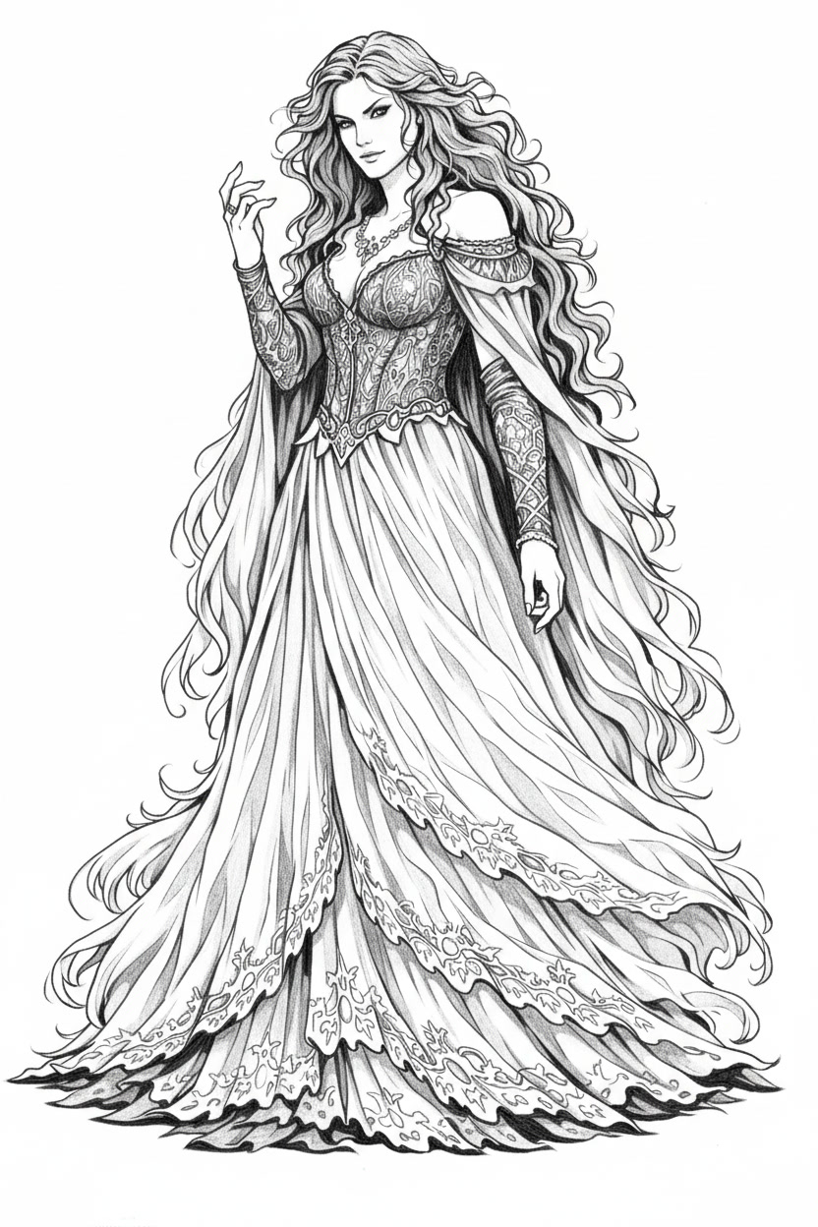
"We will keep them watching the wrong shadows," Rozh said softly. But there was ice in it. "Then we will end them."
Nare's eyes flicked to Rozh, then away. "And I sense another. "
“Two little girls?” Suden scoffed.
Rozh's voice went hard. "It is her plan. Would you question our mistress?"
Silence fell, heavy as a chain.
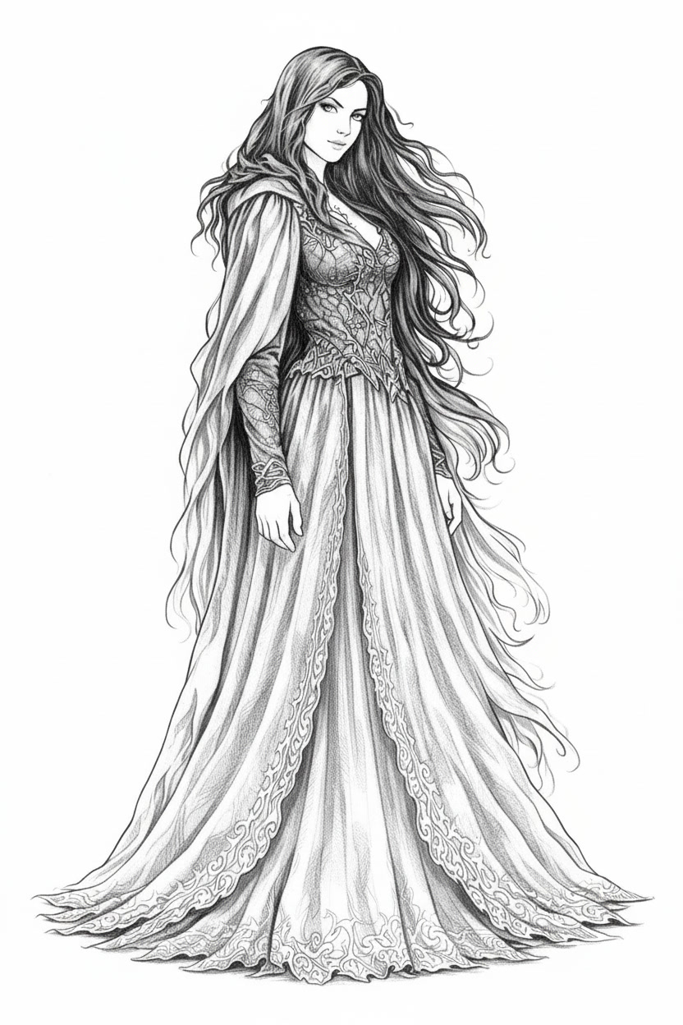
Once, long ago, they had lived in Iriy, a bright garden where fallen gods rested. Then their mistress had pulled them out, twisted them, fed them power... and bound them.
Suden broke the silence with a snort. "Two little girls. One old god. One cursed mutt. Once we have the relic, we will snuff them out."
Nare's gaze stayed on the siege. "Time bends. And when you bend it, it bends back."
"Yes, yes," Suden snapped, annoyed by her sister’s doubt. "Save the warnings."
Rozh straightened, regal and severe. "We will succeed. In the name of our mistress."
"In the name of our mistress," Suden intoned.
"In the name of our mistress," Nare echoed, grudging.
Suden stamped her foot. A purple spark spat into the night and shot down toward the castle like a cruel comet.
"The general will fall shortly," Suden said, watching it fly. Her hand unfurled, and an evil whip of crackling purple-black magic coiled into existence. "And when Veles tries to stop us...."
The three sisters turned as one. Their cloaks trailed like smoke as they drifted down the hill, quiet as mist.

